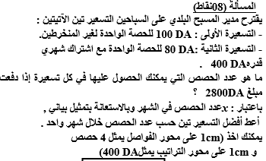

**دورة الـوضعيـة الادمــا جيـة 02**

**انا ناجح**

**انـا أولـى ثـانوي**

**2024**

..............................................................................................................................................................................................................................................................................................................................................................................................

..............................................................................................................................................................................................................................................................................................................................................................................................

..............................................................................................................................................................................................................................................................................................................................................................................................

..............................................................................................................................................................................................................................................................................................................................................................................................

...........................................................................................................................................................................................................................................................................................................................................................................................................................................................................................................................................................................................................................................................

اكتب اسمك مع الناجحين : .........................................................